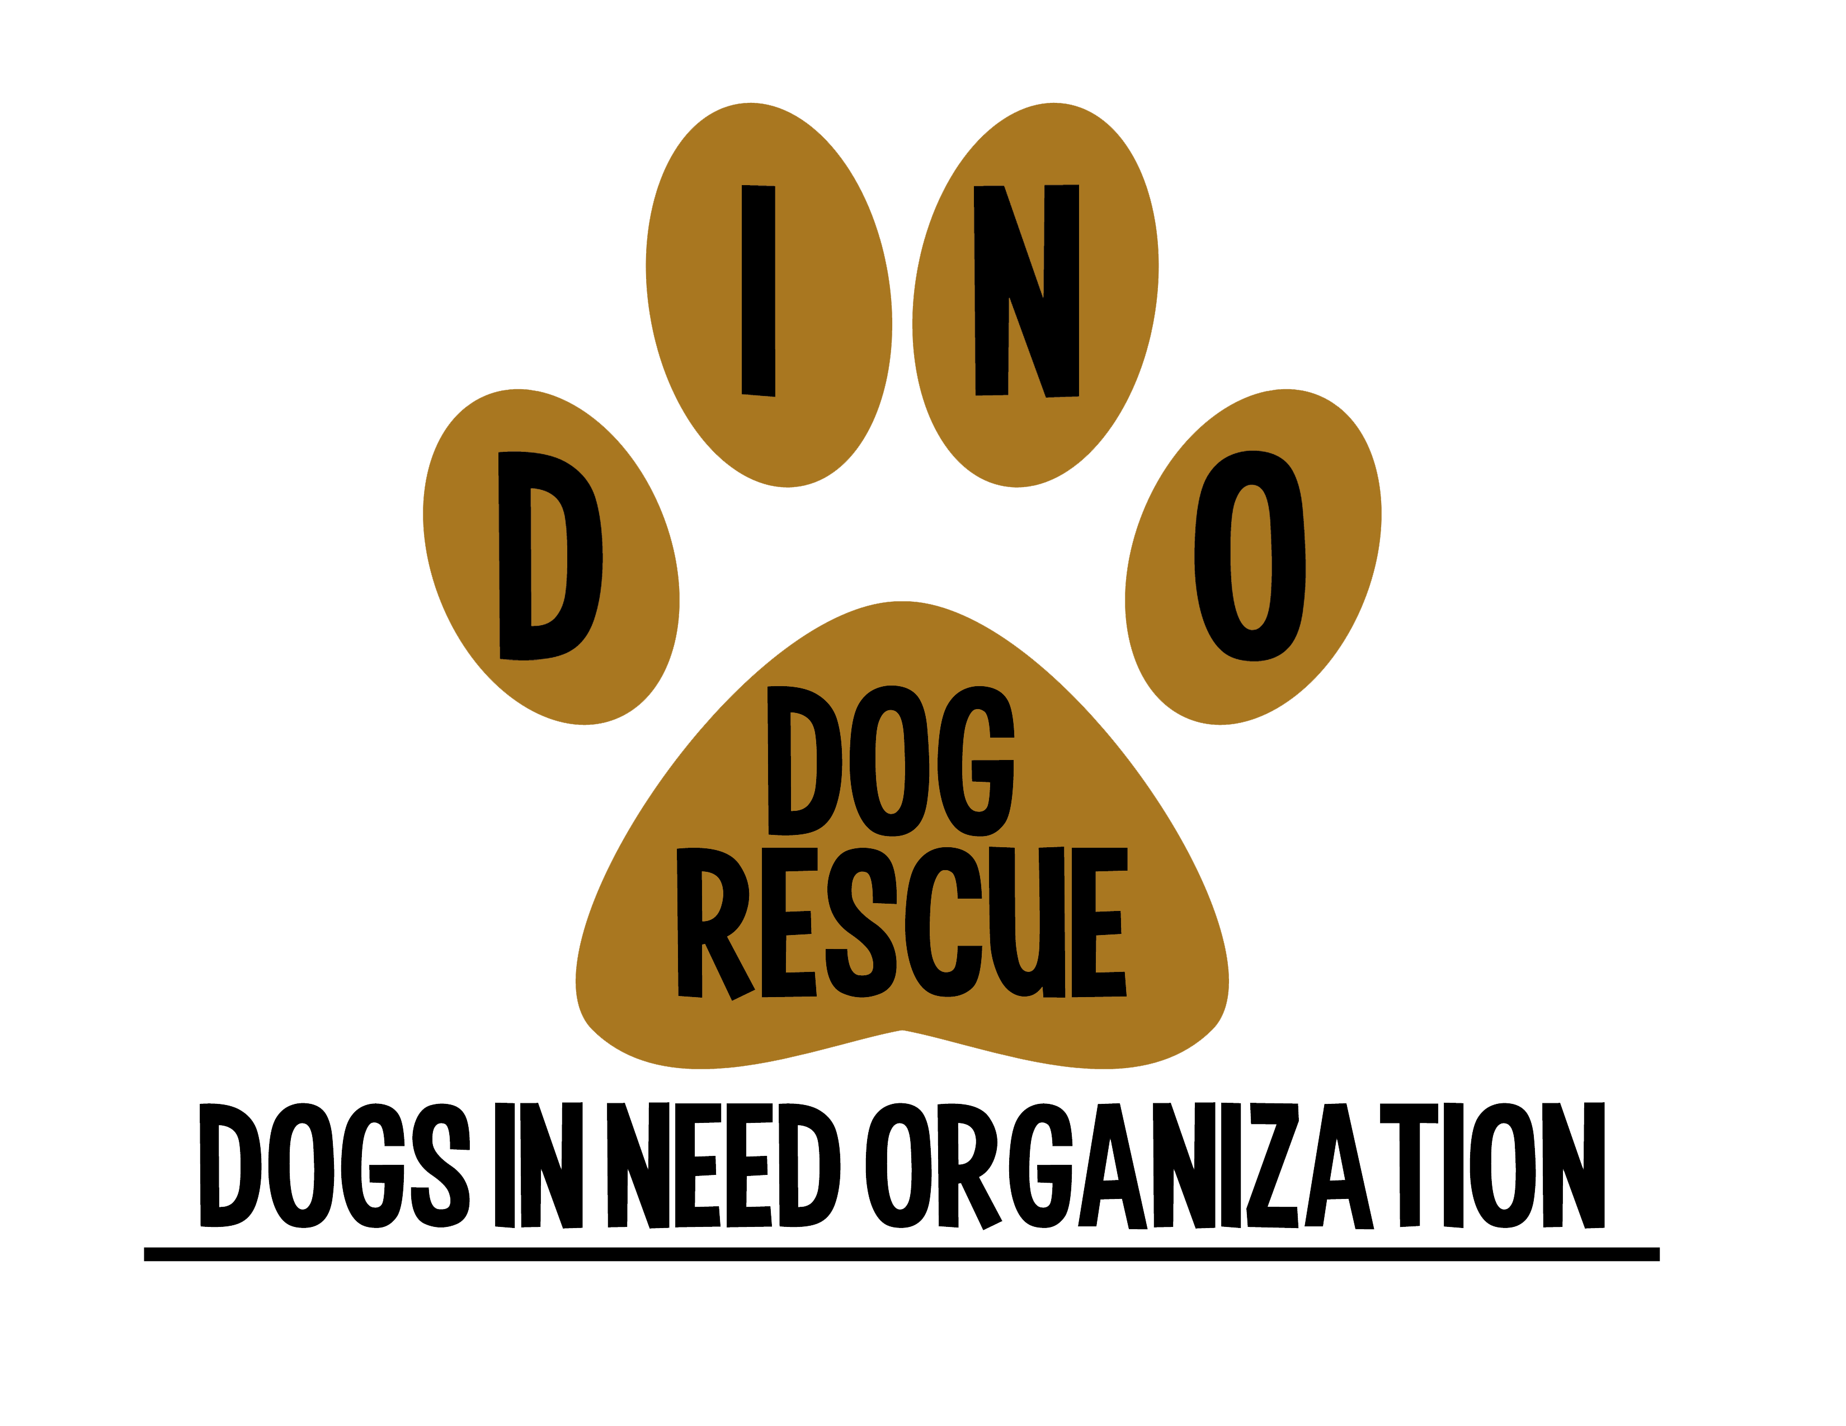 D.I.N.O. – FOSTER WAIVER
Dogs In Need Organization (D.I.N.O.) and the undersigned person (the "foster") agree to the following:

- Ownership and Placement
  - It is understood and acknowledged that D.I.N.O. maintains ownership of any and all dogs placed as a D.I.N.O. ("Foster Dog") until each Foster Dog has been formerly adopted and D.I.N.O. has received a signed adoption agreement and adoption fee pertaining to each Foster Dog.
  - D.I.N.O. is responsible for the adoption and placement of all Foster Dogs. While the input and judgment of the D.I.N.O. Foster is invaluable in D.I.N.O. 's placement efforts, all decisions concerning permanent placement shall be at the discretion of D.I.N.O. .
  - The foster shall immediately surrender custody of the Foster Dog to LMR upon demand.
- Expenses and Medical Costs. All expenses including medical care of a Foster Dog must be authorized, in writing, by D.I.N.O. D.I.N.O. assumes no responsibility nor will D.I.N.O. reimburse expenses without prior authorization. Medical care required for a Foster Dog due to neglect or disregard of D.I.N.O. policies regarding the care of the Foster Dog shall be the responsibility of the foster and shall not be subject to reimbursement.
- Emergencies. In an emergency and when seeking D.I.N.O. approval may jeopardize the Foster Dog's life, the foster may seek oral authorization from a D.I.N.O. Director or, if a D.I.N.O. Director is not readily available, the foster may in their discretion proceed to seek immediate veterinary care. With proper documentation, the foster will be reimbursed for such costs. Every attempt should be made to use a LMR participating veterinarian for medical attention.
- Neglect. Neglect is defined as:
    - Allowing the Foster Dog access to hazardous and/or harmful materials;
    - Leaving the Foster Dog outdoors while the foster is not on the premises; or
    - To in any way care for the Foster Dog in a manner deemed neglectful by either state or local ordinances and regulations.
- Relocation. If the foster cannot hold the Foster Dog until placement, the foster shall contact D.I.N.O. so that D.I.N.O. can make arrangements to place the Foster Dog into a different foster home. The foster understands and acknowledges that it may take several days to secure a new foster home and, as such, will provide D.I.N.O. with as much notice as possible of the need for relocation.
- Visits by D.I.N.O. . The foster recognizes the need to ensure that the Foster Dog is receiving proper and humane care, and agrees to allow authorized representatives of D.I.N.O. to make inquiries or inspect the foster’s home and the conditions in which the Foster Dog is living, at any reasonable time.
- Supervision. The Foster Dog shall be supervised while interacting with any and all other animals and/or children.
- Potential Adopters. The foster understands and agrees prospective adopters may wish to visit the Foster Dog before adopting and will allow prospective adopters to meet the Foster Dog at the foster home or at a mutually convenient location.

- Notification Requirements. The foster shall immediately notify D.I.N.O.:
    - Of any medical behavioral, physical or other change of condition of the Foster Dog;
    - In the event a Foster Dog is injured, dies or otherwise requires emergency medical treatment;
    - Should the Foster Dog become lost or stolen; or
    - Of any change in address, telephone number or e-mail as soon as the change occurs.
- Transfer/Location of the Foster Dog. The foster may not transfer the Foster Dog to any other person without the express written consent of D.I.N.O..
- Renting. The foster acknowledges that the residence, if rented, permits pets pursuant to the lease, or by special permission of the landlord or resident manager which permission has been obtained.
- Behavioral and / or Health Issues. The foster recognizes and understands that D.I.N.O. has made reasonable efforts to provide the foster with a Foster Dog that is compatible with the foster. Notwithstanding, the foster understands and acknowledges that D.I.N.O. has limited knowledge on the Foster Dog’s health and temperament and can only tell the foster what they have observed while in their care and / or what information, if any, the shelter or previous owner has provided to D.I.N.O. D.I.N.O. makes no representations or warranties with respect to the Foster Dog's health and temperament.
- Waiver and Liability.
  - The foster agrees not to hold D.I.N.O. , or anyone affiliated with D.I.N.O., responsible for any injury, illness or disease contracted by any other dogs or other animals privately owned by the foster, or for property damage or harm to other dogs or persons who may come into contact with Foster Dog while it is in the foster's care.
  - D.I.N.O. assumes no responsibility or liability for damages incurred, including but not limited to personal liability or damages to personal property including, but not limited to, home furnishings damaged by a Foster Dog.
- Miscellaneous.
  - All fax, mechanical and/or stamped signatures shall be treated as original signatures associated with this document.
Foster’s Information:
Name: ___________________________ Phone Number: __________________ Email: _____________________
Address: _____________________________________________________________
City/Province: __________________ Postal Code: _______________________
Signature: __________________________________ Date and Time: ______________________
D.I.N.O. Representative Signature: _____________________________
D.I.N.O. Representative’s Signature: ____________________________

